**SB_Scorebug: Parsing of messages coming from Basketball Panels and Use in XSplit**

**Objective:** Take the RS-232/422/485 signals of the most widespread basketball panels in Switzerland and convert the data to XML on a webserver. From there, the data can be used either on the web or as lower thirds on streaming TV.

**Setup Overview:**

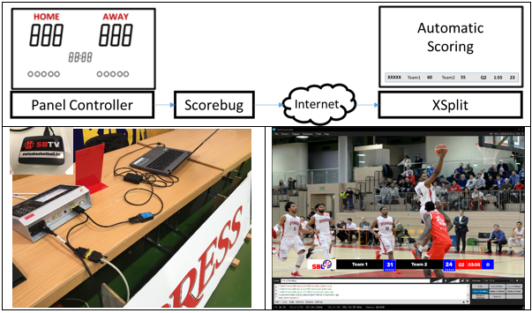

**Panel Data Specifications**

PANEL DATA: RS-232/RS-422 Input Data coming from panel / cables to be made:

* Panel Type Mobatime (RS-232 9600 Baud): see specifications from Bodet (in attachment)
* Panel Type Swiss Timing (RS-422 9600 Baud): see specifications (in attachment)
* Panel Type Stramatel (RS-485 19200 Baud): see specifications (in attachment)
* Panel Type G+D (RS-232, 19200 Baud): see specifications (in attachment) * not implemented

**Scorebug Setup (getting RS-xxx data and posting Serial Data to LAMP server)**

* Update Raspberian to latest software version
  + sudo apt-get update
  + sudo apt-get dist-upgrade
* Download and install teamviewer and attach it to Teamviewer account (for remote management, alternatively VNC can be used)
* Create in /home/pi the folder Panel2Net
* Copy Panel2Net.py into folder Panel2Net
* Edit the autostart routine in /home/pi/.config/lxsession/LXDE-pi with “nano autostart”,  
  insert additional line and quite with ^O (saving to autostart) and ^X
* Optional: Adjust screen configuration in RPI Configuration Menu to 1280x720

With ready-made image (available on demand)

**LAMP SERVER Setup (getting Serial Data and generating 2 XMLs)**

* Buy Droplet from Digitalocean (or any comparable service)
* Install ready-made LAMP server (provided by Digitalocean)
* Create /var/www/html/abcd
* Copy backend files mobatime.php, stramatel.php and swisstiming.php into directory
* Ensure with CHMOD 777 that all the directory has full access

**XSPLIT CONFIGURATION**

* Load the relevant background image for the panel
* Create as many text fields as required

|  |  |
| --- | --- |
|  |  |
|  |  |

The fields that can be used are the following

|  |  |
| --- | --- |
| <StartTag>Example Entry</EndTag> | Description |
| <ScoreTeamA>14</ScoreTeamA> | Score Home Team |
| <ScoreTeamB>21</ScoreTeamB> | Score Away Team |
| <TeamFoulA>5</TeamFoulA> | Team Fouls Home Team |
| <TeamFoulB>5</TeamFoulB> | Team Fouls Away Team |
| <TimeOutA>1</TimeOutA> | Timeouts Home Team |
| <TimeOutB>1</TimeOutB> | Timeouts Away Team |
| <Quarter>Q1</Quarter> | Quarter Q1 – Q4 and E for Extratime |
| <StartStop>START</StartStop> | Clock Started or Stopped |
| <Timeout>No</Timeout> | Timeout Running Yes/No |
| <ClockTime>01:01</ClockTime> | ClockTime |
| <ClockTimeOut>00</ClockTimeOut> | TimeOut Countdown |
| <ShotClock> 8</ShotClock> | Shotclock |
| <UTCTime>2018-01-02 16:05:57</UTCTime> | UTC Time (added by server, not coming from console) |

**Appendix: Output XML Data (last action), for definitions of data structure, see Appendix 1 - 4**

|  |  |  |  |  |  |
| --- | --- | --- | --- | --- | --- |
|  | SwissTiming (Chapter – Byte) | Mobatime/Bodet (Message – Byte) | Stramatel (Position in 54 byte statement) | G+D (Position in 3x60 char statement) | |
| <document> | - | - | - | - | |
| <event> | - | - | - | - | |
| <TeamA>BONCOURT</TeamA> | 4.1 – 3 | n/a, write LOCAL | n/a, write LOCAL | n/a, write LOCAL | |
| <TeamB>MONTHEY</TeamB> | 4.1 – 15 | n/a, write VISITOR | n/a, write VISITOR | n/a, write VISITOR | |
| <ScoreTeamA>86</ScoreTeamA> | 3.2 – 8 | 30 – 4 to 6 | 9-11 | Data1/1-3 | |
| <ScoreTeamB>66</ScoreTeamB> | 3.2 - 11 | 30 – 7 to 9 | 12-14 | Data1/4-6 | |
| <TeamFoulA>4</TeamFoulA> | 3.2 – 14 | 31 – 5 | 16 | Data1/7-8 | |
| <TeamFoulB>4</TeamFoulB> | 3.2 – 15 | 31 – 7 | 17 | Data1/12-13 | |
| <TimeOutA>4</TimeOutA> | 3.2 – 16 | 18 – 9 | 18 | n/a | |
| <TimeOutB>4</TimeOutB> | 3.2 – 17 | 18 – 10 | 19 | n/a | |
| <Quarter>Q4</Quarter> | 3.2 – 18 | 18 – 13 | 15 | Data1/10 | |
| <StartStop>START</StartStop> | 3.2 – 20 | 18 – 3b1 | 21 | Calculated? | |
| <Timeout>Yes</Timeout> | 3.2 – 22 | 19 – 4 and 5 | 22 | Calculated? | |
| <ClockTime>00:00</ClockTime> | 3.2 – 3 | 18 – 5 to 8 | 5-8 | Data1/15-19 | |
| <ClockTimeOut>00</ClockTimeOut> | 3.2 – 22 | 19 – 6 and 7 | 22,47-48 |  |
| <ShotClock>00</ShotClock> | 3.2 - 24 | 50 – 4 and 5 | 53 |  |
| <UTCTime>2017-09-21 21:14:57</UTCTime> | 3.9 – calculated | 20 – calculated (taking date from server) | n/a – calculated (taking date from server) | n/a – calculated (taking date from server) | |
| </event> | - | - | - | - | |
| </document> | - | - | - | - | |

**Output XML Data (history), for definitions of data structure, see Appendix 1 - 4**

|  |  |  |  |  |
| --- | --- | --- | --- | --- |
|  | SwissTiming | Mobatime/Bodet | Stramatel | G+D |
| <document> | - |  |  |  |
| <playerinfo> | - | - | - | - |
| <PlayerinfoA=NumberOfPlayers> | Calculated | Calculated | Calculated | Calculated |
| <ShirtNo>XX</ShirtNo><Points>XX</Points><Fouls>XX</Fouls> | 3.3 and 3.5 | 37, 58 – 4 to 8, 33 – 4 to 15 | ShirtNo n/a, Points n/a, 23 | Data2/1-2, Data2/4-5, Data2/3 |
| … | - |  |  |  |
| <ShirtNo>XX</ShirtNo><Points>XX</Points><Fouls>XX</Fouls> | 3.3 and 3.5 | 37, 58 – 4 to 8, 33 – 4 to 15 | No shirts, no points, 34 | Data2/56-57, Data2/59-60, Data2/58 |
| </PlayerinfoA> | - |  |  |  |
| <PlayerinfoB=NumberOfPlayers> | Calculated | Calculated | Calculated | Calculated |
| <ShirtNo>XX</ShirtNo><Points>XX</Points><Fouls>XX</Fouls> | 3.4 and 3.6 | 38, 58 – 4 to 8, 33 – 4 to 15 | No shirts, no points, 35 | Data3/1-2, Data3/4-5, Data3/3 |
| … | - |  |  |  |
| <ShirtNo>XX</ShirtNo><Points>XX</Points><Fouls>XX</Fouls> | 3.4 and 3.6 | 38, 58 – 4 to 8, 33 – 4 to 15 | No shirts, no points, 46 | Data3/56-57, Data3/59-60, Data3/58 |
| </PlayerinfoB> | - | - | - | - |
| </playerinfo> | - | - | - | - |

(continued)

|  |  |  |  |  |
| --- | --- | --- | --- | --- |
| <playbyplay> | - | - | - | - |
| <event> | - | - | - | - |
| <TeamA>BONCOURT</TeamA> | 4.1 – 3 | n/a, write LOCAL | n/a, write LOCAL | n/a, write LOCAL |
| <TeamB>MONTHEY</TeamB> | 4.1 – 15 | n/a, write VISITOR | n/a, write VISITOR | n/a, write VISITOR |
| <ScoreTeamA>86</ScoreTeamA> | 3.2 – 8 | 30 – 4 to 6 | 9-11 | 1-3 |
| <ScoreTeamB>66</ScoreTeamB> | 3.2 - 11 | 30 – 7 to 9 | 12-14 | 4-6 |
| <TeamFoulA>4</TeamFoulA> | 3.2 – 14 | 31 – 5 | 16 | 7-8 |
| <TeamFoulB>4</TeamFoulB> | 3.2 – 15 | 31 – 7 | 17 | 12-13 |
| <TimeOutA>4</TimeOutA> | 3.2 – 16 | 18 – 9 | 18 | n/a |
| <TimeOutB>4</TimeOutB> | 3.2 – 17 | 18 – 10 | 19 | n/a |
| <Quarter>Q4</Quarter> | 3.2 – 18 | 18 – 13 | 15 | 10 |
| <StartStop>START</StartStop> | 3.2 – 20 | 18 – 3b1 | 21 | Calculated? |
| <Timeout>Yes</Timeout> | 3.2 – 22 | 19 – 4 and 5 | 22 | Calculated? |
| <ClockTime>00:00</ClockTime> | 3.2 – 3 | 18 – 5 to 8 | 5-8 | 15-19 |
| <ClockTimeOut>00</ClockTimeOut> | 3.2 – 22 | 19 – 6 and 7 | 22,47-48 |  |
| <ShotClock>00</ShotClock> | 3.2 - 24 | 50 – 4 and 5 | 53 |  |
| <UTCTime>2017-09-21 21:14:57</UTCTime> | 3.9 – calculated | 20 – calculated (taking date from server) | 20 – calculated (taking date from server) | 20 – calculated (taking date from server) |
| </event> | - | - | - | - |
| … | - | - | - | - |
| <event> | - | - | - | - |
| As above | - | - | - | - |
| </event> | - | - | - | - |
| </playbyplay> | - | - | - | - |
| </document> | - | - | - | - |

**Appendix1: Documentation from SwissTiming**

** **

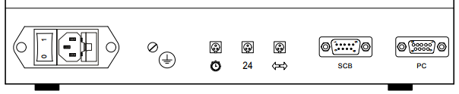

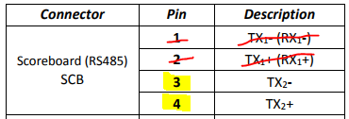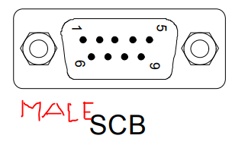

** **

<https://www.mouser.ch/ProductDetail/Amphenol-Tuchel/C016-30H006-100-10/?qs=sGAEpiMZZMvG94qpybaIZUbMDiDcULcBqJT0ZjJ9mHY%3d>

<https://www.mouser.ch/ProductDetail/Amphenol-Tuchel/C016-30D006-100-10/?qs=sGAEpiMZZMvG94qpybaIZUbMDiDcULcBY3rMQk%2f%2fEWE%3d>

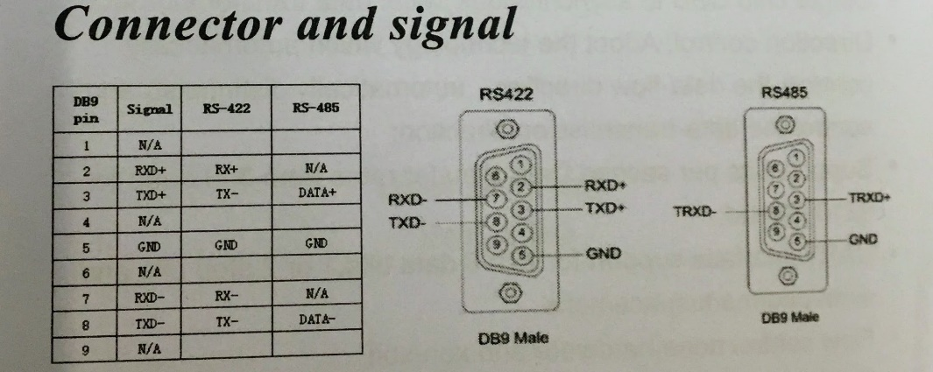

**Appendix2: Documentation Bodet/Mobatime**



**Appendix3: Documentation Stramatel (incl. Cable Manufacturing)**



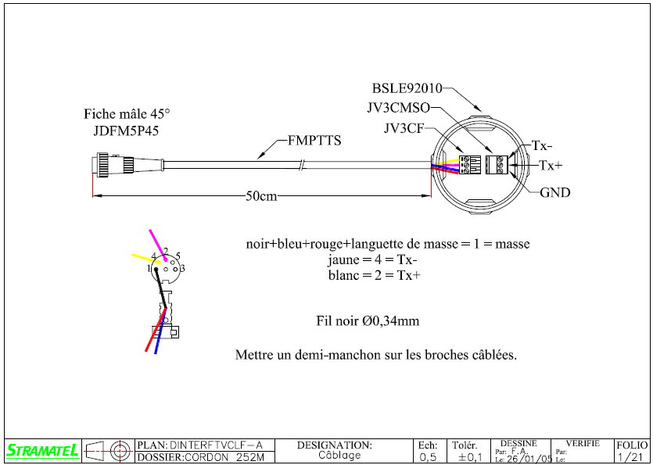

Wikipedia: A common de-facto standard is the use of: TX+/RX+ or D+ as alternative for B (high for MARK i.e. idle); TX-/RX- or D- as alternative for A (low for MARK i.e. idle)

**Appendix4: Documentation G+D**

